Name: ________________________________________ Date: _______________ Period: _______

Science Final Review

- List the steps of the Scientific Method?

- What is the difference between an observation and an inference? Give an example for each.

- List 3 conditions when you would be required to wear safety goggles during an 8th Grade Science experiment (we do not dissect in 8th Grade).

- List the purpose of each type of equipment and what it measures.
  - Graduated Cylinder:
  - Celsius Thermometer:
  - Meter Stick:
  - Goggles:
  - Spring Scale:
  - Beaker:
  - Triple Beam Balance:

- Write the definition and the metric unit for each of the following:
  - Volume:
  - Mass:
  - Temperature:
  - Density:
  - Force:
  - Work:

- What is the difference between potential and kinetic energy?

- What is the difference between a balanced force and an unbalanced force?

- Balanced forces cause objects to…

- Unbalanced forces cause objects to…

- What is the formula for work?

- Define speed, velocity, and acceleration then write an example for each.
  - Speed:
  - Velocity:
  - Acceleration:

- What is the formula for speed?

- KNOW HOW TO READ A DISTANCE-TIME GRAPH AND A SPEED-TIME GRAPH.

- What is Newton’s 1st Law?

- What is Newton’s 2nd Law?

- What is Newton’s 3rd Law?

- Define density and write the formula for density.

- Define weathering, erosion, and deposition.
  - Weathering:
  - Erosion:
  - Deposition:

- What is the continental drift theory and who proposed this theory?

- List 3 types of evidence to help support the continental drift theory?

- Fill in the table about the types of plate boundaries.

Type of Boundary | Sketch of Boundary | Direction of Movement | Types of Features
Divergent Plate Boundary
Transform Plate Boundary
Convergent Plate Boundary (Collision)
Convergent Plate Boundary (Subduction)

- A topographical map shows-
  - Earth’s layers
  - the mineral content of the rocks
  - the shape of the Earth’s surface
  - Earth’s climate

- Fill in the following chart:
 | Charge | Location | AMU | Function/Role
Protons
Electrons
Neutrons

- Following the instructions below to complete the periodic table:
  - Metals: circle/outline green
  - Metalloids: circle/outline yellow
  - Nonmetals: circle/outline blue
  - Alkali Metals: color red
  - Alkaline Earth Metals: color orange
  - Halogens: color purple
  - Noble Gases: color brown
  - Most Reactive Metal Group/Family: draw a star above this group/family
  - Most Reactive Nonmetal Group/Family: draw a star above this group/family
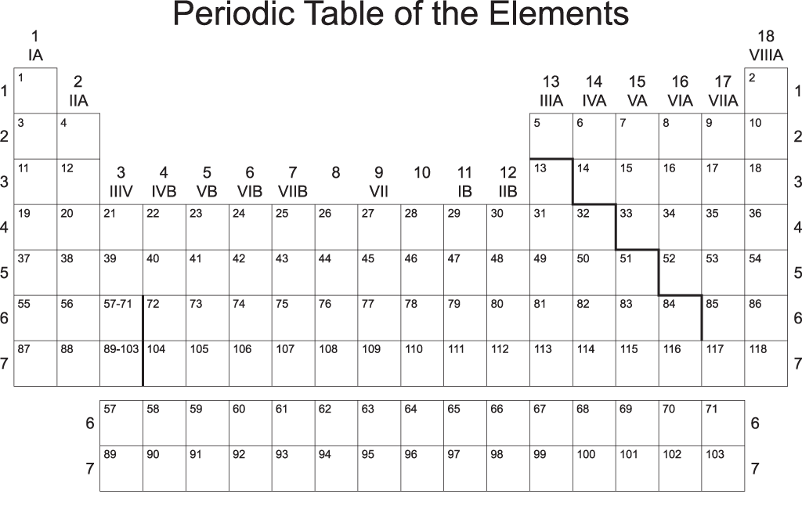

- What do the following stand for?
  - A=P=E
  - M-A=N

- Identify the following elements:


  

