Name: ________________________________________ Date: _______________ Period: _______

Final Exams 2017 Review

- List the steps of the Scientific Method?
Question, Hypothesis, Experiment, Analysis, Conclusion

- What is the difference between an observation and an inference? Give an example for each.
Observation is the process of watching someone or something. Example is anything that you can perceive with your senses.

Inference - Conclusion based on facts observed relevant with subject of observation.
For example, based on the data, there are more woman in USA than men.

- List 3 conditions when you would be required to wear safety goggles during an 8th Grade Science experiment (we do not dissect in 8th Grade).
  - When dealing with smoke/Fire
  - When dealing with glassware
  - When dealing chemicals

- List the purpose of each type of equipment and what it measures.
  - Graduated Cylinder: Measure Liquid most accurately
  - Celsius Thermometer: Measure how hot or cold an object is.
  - Meter Stick: Measures short distance
  - Goggles: Protect the eye from chemicals/heat/fire etc.
  - Spring Scale: Measures weight or force.
  - Beaker: Measures the volume of liquid.
  - Triple Beam Balance: Measures mass of objects.

- Write the definition and the metric unit for each of the following:
  - Volume: The space occupied by an object (mL or Cm³)
  - Mass: The amount of matter in an object (grams)
  - Temperature: The hotness or coldness of an object (Celsius)
  - Density: Mass divided by volume ( g/mL org/cm³⁾
  - Force: A pull or push of an object (Newtons—N)
  - Work: Force x Distance (Joules—J)

- What is the difference between potential and kinetic energy?
Potential Energy is stored energy
Kinetic Energy is energy of motion or movement.

- What is the difference between a balanced force and an unbalanced force?
Balanced Force—two forces with equal size of force (N) or maybe acting in the opposite direction of an object.
Unbalanced Force—Here, two forces are Unequal in size.

- Balanced forces cause objects to…
  - Stays at constant speed
  - Stays at rest
  - Stays at rest but changes shape.

- Unbalanced forces cause objects to…
  - Slows down
  - Speeds up
  - Stop
  - Starts
  - Change in direction
  - Change shape

- What is the formula for work? W = FxD

- Define speed, velocity, and acceleration then write an example for each.
  - Speed: Distance divide by time
  - Velocity: Speed and direction
  - Acceleration: This is the change in velocity (not change in speed)

- What is the formula for speed? Distance/ Time

- KNOW HOW TO READ A DISTANCE-TIME GRAPH AND A SPEED-TIME GRAPH.

- What is Newton’s 1st Law? It states that an object at rest remains at rest and an object in motion remain in motion unless acted upon by an external or outside force.

- What is Newton’s 2nd Law? This law states that Force = Mass x Acceleration.

- What is Newton’s 3rd Law? For every action, there is equal and opposite reaction.

- Define density and write the formula for density. Density is the Mass of an object divided by the Volume

- Define weathering, erosion, and deposition.
  - Weathering: The chemical & physical process that breakdown rocks.
  - Erosion: The process of removing weathered rock & soil
  - Deposition: The process where sediments (rocks & soil) are deposited in a new locations)

- What is the continental drift theory and who proposed this theory?
This theory was proposed by Alfred Wegner. It states that our continent once used to be a huge landmass called Pangea/ Pangaea which was separated by plate tectonics.

- List 3 types of evidence to help support the continental drift theory?
a.Fossils & glacial evidence
b.Continetal Fit like a puzzle
c.Land forms and rock layers.

- Fill in the table about the types of plate boundaries.

Type of Boundary | Sketch of Boundary | Direction of Movement | Types of Features
Divergent Plate Boundary |  | Plates move apart | 1. Rift valley  2. Seafloor spreading  3. Volcanoes  4. Mid ocean ridge
Transform Plate Boundary |  | Plates slide past each other | - Faults  - Earthquake
Convergent Plate Boundary (Collision) |  | Plates move in or come together | An uplift (Mountains,  Ridges)
Convergent Plate Boundary (Subduction) | 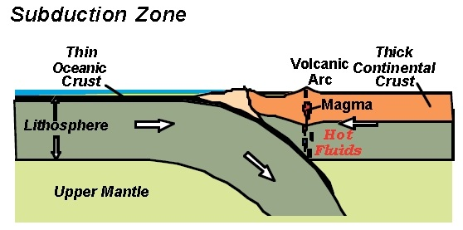 | Denser plate subducts | Volcanic Island  Trenches  Volcanoes  jTrn

- A topographical map shows-Choose the correct answer
  - Earth’s layers
  - the mineral content of the rocks
  - the shape of the Earth’s surface
  - Earth’s climate

- Fill in the following chart:
 | Charge | Location | AMU | Function/Role
Protons | + | Inside nucleus | 1 amu | Identifies the element
Electrons | __ | Electron cloud/ outside nucleus | < 1amu | Chemical reactivity
Neutrons | No charge/neutral | Inside nucleus | 1 amu | Determines mass

- Following the instructions below to complete the periodic table:
  - Metals: circle/outline green
  - Metalloids: circle/outline yellow
  - Nonmetals: circle/outline blue
  - Alkali Metals: color red
  - Alkaline Earth Metals: color orange
  - Halogens: color purple
  - Noble Gases: color brown
  - Most Reactive Metal Group/Family: draw a star above this group/family
  - Most Reactive Nonmetal Group/Family: draw a star above this group/family

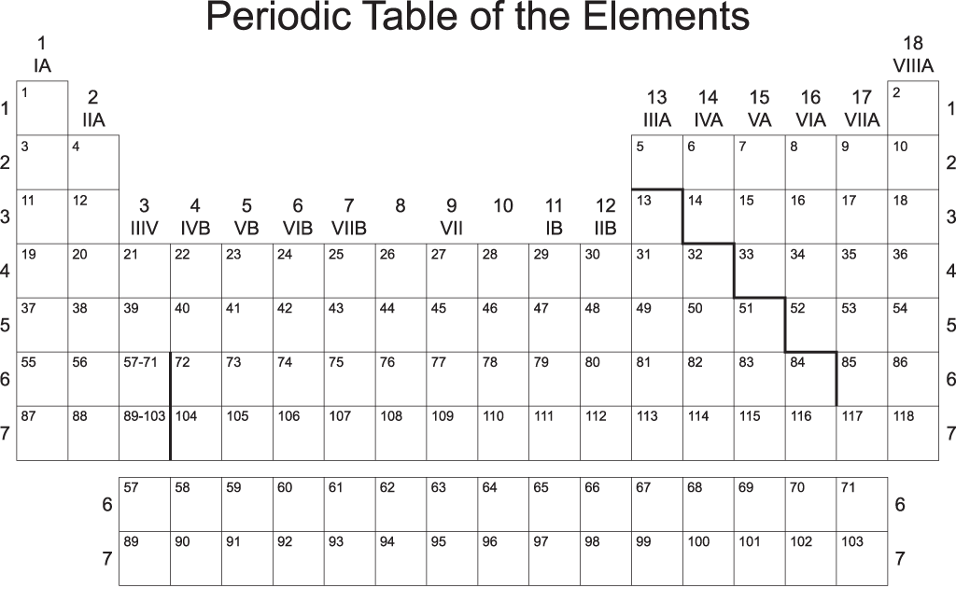

- What do the following stand for?

  - A=P=E—Atomic # = Proton # = Electrons
  - M-A=N—Mass #--Atomic = Neutron

- Identify the following elements:

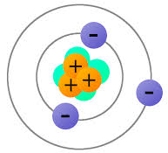
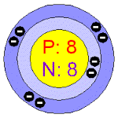
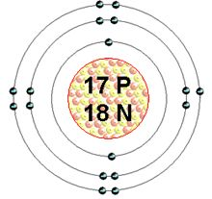
_____________________ ________________Oxygen__________ ______Lithium______ _____Chlorine_____

Ecology
27. Explain the following ecological terms
- Ecosystem—All living and nonliving things that interact in an area

- Community—All the populations that live in an area at the same time.

- Population—Organisms of one species living in the same place at the same time.
28.Name the 3 types of Symbiotic relationships
a. Mutualism
b. Commensalism
c. Parasitism
29.A bird eats ticks on a cow’s body. What feeding relationship is this? Mutualism
30.The first level of a food chain begins with the Sun. TRUE/FALSE
31.What is the difference between a
- Food chain—This shows how the energy in food is passed from one organism to another in an ecosystem

- Food web—A pattern of overlapping food chains in an ecosystem

32.If producers are autotrophs, consumers will be known as__heterotrophs_________
33.What do the arrows indicate on a food web and food chain?
The flow of energy.
34.Briefly describe the difference between
- Parasite—An organism that lives in or on the body of another organism causing harm to that organism

- Host—The organism that is being harmed by a parasite

35.What is a decomposer? An organism that breaks down the remains of dead plants or animals for consumption.
36.Name 4 examples of decomposers
a. Mushrooms
b. Termites
c. Molds
d. Caterpillars
11. What are biotic and abiotic factors?
Biotic factors are living things in the environment such as plants & animals.
Abiotic factors are non-living things in an environment
12. Examples of biotic and abiotic are
a. Biotic Factors—Trees, fox, butterfly, diseases, horses etc.
b. Abiotic Factors—Rocks, temperature, air, soil, wind, water

13. Give 4 examples of a predator-prey feeding relationships
- A lion—Water buffalo
- A hyena--antelopes
- Shark--humans
- Hawk--snakes
- Humans—Deer
14. Define the following ecological terms
- Mutualism—A feeding relationship where both organisms benefit from each other

- Commensalism—A feeding relationship where one organism benefits and the other neither benefits nor is harmed.

- Parasitism –A feeding relationship where one organism lives in or on another organism causing harm

15. What is the difference between the following?
- Photosynthesis—The process where plants manufacture their food using CO2 + H2O and Sunlight
- Chemosynthesis—The process where sea plants manufacture their own food using chemicals instead of sunlight.

Lunar Phases, Tides, and Seasons
- What causes seasons on Earth?
The tilt of Earth’s axis
- Where does the Earth’s axis pass through?
Poles (North and South)
- What angle does the Earth’s axis tilt?
23.5 degrees
- Where does the Earth’s axis point?
Always toward the North Star (Polaris)
- Why is the Northern Hemisphere warm during the summer?
It is tilted toward the sun
- If it is winter in the Southern Hemisphere, what season is it in the Northern Hemisphere?
Summer
- During what two months is the Earth’s axis not pointing toward or away from the Sun?
March and September

- How much solar energy do the Northern and Southern Hemispheres receive during the spring and fall seasons?
Equal amounts
- Define tides.
The alternating rise and fall of the sea. Occurs 4x a day.
- Where do tides occur?
Ocean
- What causes tides?
The moons & Sun’s gravitational pull
- How long does it take for the Moon to go through all its phases?
29.5 days
- Why is the Moon visible?
It reflects the light from the Sun
- Why isn’t the Moon visible during a new Moon phase?
The lighted portion of the moon faces away from Earth
- What does ‘wax’ mean?
To “grow”. To get bigger.
- What does ‘wane’ mean?
To shrink, get smaller, darker
- Define spring tides.
Occurs during Full moon and new moon. High, high tides and low, low tides
- Define neap tides.
Occurs during 1st and 3rd quarter moons. Hard to notice high and low tides
- How are the Sun, Moon, and Earth aligned during ‘spring tides’?
Straight line
- Describe when spring tides occur during the month.
Full moon and new moon

- Describe when neap tides occur during the month.
1st and 3rd quarter moon
- Is it possible to predict tides?
Yes, we can do so accurately
- What does the Moon’s gravity do to the Earth’s waters?
Pulls on them toward the moon and causes tides
- Know how to label the 8 phases of the Moon.

ASTRONOMY—Universe

- What is a light year?
  - Distance that light travels in one year
- What is the definition of parallax?
  - The method used to determine a stars distance from earth
  - The apparent movement of an object viewed from different positions—remember the thumb experiment
- What 3 ways are stars classified by?
  - Size, brightness, and temperature
- The hottest stars are what color?
  - Blue-White
- What type of magnitude is it when stars brightness can be seen from earth?
  - Apparent magnitude
- In the HR diagram, the main sequence stars are what in relation to temperature and brightness?
  - They increase in brightness as they increase in temperature
- What happens to make create a star?
  - Contracting gas and dust get so hot that nuclear fusion starts

- What is the first stage in the life of a star?
  - Nebula –stars are born here
  - Protostar—1st Stage
- What is the force that pulls matter in a nebula?
  - Gravity
- A star’s lifetime depends on what?
  - It’s mass
- A supernova is the explosion of a dying ?
  - A giant or supergiant star
- The first thing that a star becomes when it runs out of fuel is?
  - White dwarf.
- How are black holes created?
  - From the most massive stars collapse. It falls inward on itself.
- What does a white dwarf become when it stops glowing?
  - Black Dwarf.
- How are elliptical galaxies and spiral galaxies different?
  - Elliptical galaxies vary more in shape than spiral galaxies
- What type of galaxy is the Milky Way?
  - Spiral galaxy
- What is the name of the theory that astronomers developed to describe the beginning of the universe?
  - The Big Bang
- What is a piece of evidence that supports the big bang theory?
  - That the galaxies seen are moving AWAY from our galaxy
- What did the solar system form from?
  - An enormous explosion of a tiny fire ball.

- When the solar system formed, the sphere that lost most of their gasses became what?
  - Inner planets
- The most massive stars become when they die.
  - Neutron stars or black holes
- What is the magnitude called when a star is a standard distance from the earth?
  - Absolute magnitude
- Galaxies without regular shape are classified as what type of galaxy?
  - Irregular galaxies
- Astronomers have said that our universe’s age can be inferred due to how fast the universe is:
  - Expanding or moving away
  - Shrinking
  - Making new stars
  - Making black holes
- Some astronomers believe the universe began with an enormous explosion called ?
  - The Big Bang
- BE ABLE TO READ THE HR DIAGRAM AND ANSWER QUESTIONS ABOUT IT

- When a white dwarf stops glowing, it becomes what color dwarf?
  - Black Dwarf
- A neutron star forms from what other type of star?
  - Supernova
- What 2 ways can a star go after becoming a super nova?
  - Black hole or a neutron star
- What is the word that describes all of space and everything in it?
  - The Universe
- BE ABLE TO READ SPECTRAL DATA AND DETERMINE WHAT ELEMENT IS IN THE STARS

- The spectrum for visible wavelengths emitted by Star X is compared to the Emission spectra of four different elements. According to the spectral analysis data, which element is present in Star X?
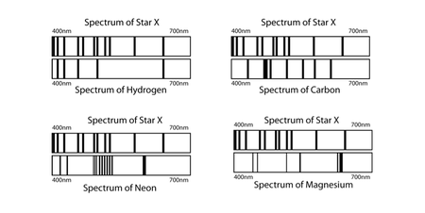
A. Carbon
B. Neon
C. Hydrogen
D. Magnesium

