Name: _______________________________________ Date: _______________ Period: _____

Final Exams 2018 Review

1. Fill in the following chart:
 | Charge | Location | AMU | Function/Role
Protons | + | Inside nucleus | 1 amu | Identifies the element
Electrons | __ | Electron cloud/ outside nucleus | < 1amu | Chemical reactivity
Neutrons | No charge/neutral | Inside nucleus | 1 amu | Determines mass

2. Following the instructions below to complete the periodic table:
a. Metals: circle/outline green
b. Metalloids: circle/outline yellow
c. Nonmetals: circle/outline blue
d. Alkali Metals: color red
e. Alkaline Earth Metals: color orange
f. Halogens: color purple
g. Noble Gases: color brown
h. Most Reactive Metal Group/Family: draw a star above this group/family
i. Most Reactive Nonmetal Group/Family: draw a star above this group/family
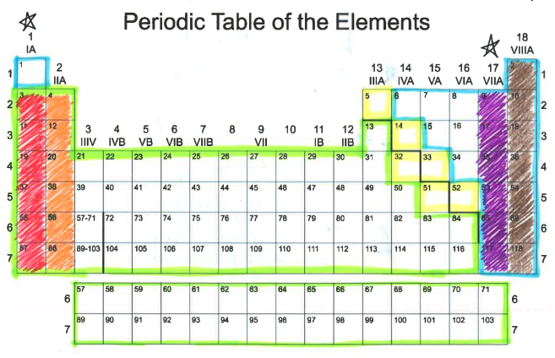
3. What do the following stand for?
a. A=P=E—Atomic # = Proton # = Electrons
b. M-A=N—Mass #--Atomic = Neutron

4. Identify the following elements:

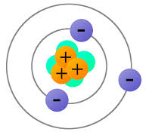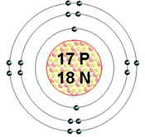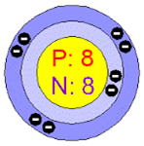

______Lithium______ _____Chlorine_____ __________Oxygen__________

Ecology
5. Explain the following ecological terms
a. Ecosystem—All living and nonliving things that interact in an area

b. Community—All the populations that live in an area at the same time.

c. Population—Organisms of one species living in the same place at the same time.

6. Name the 3 types of Symbiotic relationships
a. Mutualism
b. Commensalism
c. Parasitism

7. A bird eats ticks on a cow’s body. What feeding relationship is this? Mutualism

8. The first level of a food chain begins with the Sun. TRUE/FALSE

9. What is the difference between a
a. Food chain—This shows how the energy in food is passed from one organism to another in an ecosystem

b. Food web—A pattern of overlapping food chains in an ecosystem

10. If producers are autotrophs, consumers will be known as__heterotrophs_________

11.What do the arrows indicate on a food web and food chain?
The flow of energy.
12.Briefly describe the difference between
a. Parasite—An organism that lives in or on the body of another organism causing harm to that organism

b. Host—The organism that is being harmed by a parasite

13.What is a decomposer? An organism that breaks down the remains of dead plants or animals for consumption.

14. Name 4 examples of decomposers
a. Mushrooms
b. Termites
c. Molds
d. Fungus

15. What are biotic and abiotic factors?
Biotic factors are living things in the environment such as plants & animals.
Abiotic factors are non-living things in an environment

16. Examples of biotic and abiotic are
a. Biotic Factors—Trees, fox, butterfly, diseases, horses etc.
b. Abiotic Factors—Rocks, temperature, air, soil, wind, water

17. Give 4 examples of a predator-prey feeding relationships
a. A lion—Water buffalo
b. A hyena--antelopes
c. Shark--humans
d. Hawk--snakes
e. Humans—Deer

18. Define the following ecological terms
a. Mutualism—A feeding relationship where both organisms benefit from each other

b. Commensalism—A feeding relationship where one organism feeds

c. Parasitism –A feeding relationship where one organism lives in or on another organism causing harm

19. What is the difference between the following?
a. Photosynthesis—The process where plants manufacture their food using CO2 + H2O and Sunlight
b. Chemosynthesis—The process where sea plants manufacture their own food using chemicals instead of sunlight.

Lunar Phases, Tides, and Seasons
1. What causes seasons on Earth? The tilt of Earth’s axis

2. Where does the Earth’s axis pass through? Poles (North and South)

3. What angle does the Earth’s axis tilt? 23.5 degrees

4. Where does the Earth’s axis point? Always toward the North Star (Polaris)

5. Why is the Northern Hemisphere warm during the summer? It is tilted toward the sun

6. If it is winter in the Southern Hemisphere, what season is it in the Northern Hemisphere? Summer

7. During what two months is the Earth’s axis not pointing toward or away from the Sun? March and
September

8. How much solar energy do the Northern and Southern Hemispheres receive during the spring and fall seasons? Equal amounts

9. Define tides. The alternating rise and fall of the sea. Occurs 4x a day.

10. Where do tides occur? Ocean

11. What causes tides? The moons & Sun’s gravitational pull

12. How long does it take for the Moon to go through all its phases? 29.5 days

13. Why is the Moon visible? It reflects the light from the Sun

14. Why isn’t the Moon visible during a new Moon phase? The lighted portion of the moon faces away from Earth

15. What does ‘wax’ mean? To “grow”. To get bigger.

16. What does ‘wane’ mean? To shrink, get smaller, darker

17. Define spring tides. Occurs during Full moon and new moon. High, high tides and low, low tides

18. Define neap tides. Occurs during 1st and 3rd quarter moons. Hard to notice high and low tides

19. How are the Sun, Moon, and Earth aligned during ‘spring tides’? Straight line

20. Describe when spring tides occur during the month. Full moon and new moon

21. Describe when neap tides occur during the month. 1st and 3rd quarter moon

22. Is it possible to predict tides? Yes, we can do so accurately

23. What does the Moon’s gravity do to the Earth’s waters? Pulls on them toward the moon and causes tides

24. Know how to label the 8 phases of the Moon.

ASTRONOMY—Universe

1. What is a light year?
a. Distance that light travels in one year

2. What is the definition of parallax?
a. The method used to determine a stars distance from earth
b. The apparent movement of an object viewed from different positions—remember the thumb experiment

3. What 3 ways are stars classified by?
a. Size, brightness, and temperature

4. The hottest stars are what color?
a. Blue-White

5. What type of magnitude is it when stars brightness can be seen from earth?
a. Apparent magnitude

6. In the HR diagram, the main sequence stars are what in relation to temperature and brightness?
a. They increase in brightness as they increase in temperature

7. What happens to make create a star?
a. Contracting gas and dust get so hot that nuclear fusion starts

8. What is the first stage in the life of a star?
a. Nebula –stars are born here
b. Protostar—1st Stage

9. What is the force that pulls matter in a nebula?
a. Gravity

10. A star’s lifetime depends on what?
a. It’s mass

11. A supernova is the explosion of a dying_____________
a. A giant or supergiant star

12. The first thing that a star becomes when it runs out of fuel is?
a. White dwarf.
13. How are black holes created?
a. From the most massive stars collapse. It falls inward on itself.

14. What does a white dwarf become when it stops glowing?
a. Black Dwarf.

15. How are elliptical galaxies and spiral galaxies different?
a. Elliptical galaxies vary more in shape than spiral galaxies

16. What type of galaxy is the Milky Way?
a. Spiral galaxy

17. What is the name of the theory that astronomers developed to describe the beginning of the universe?
a. The Big Bang

18. What is a piece of evidence that supports the big bang theory?
a. That the galaxies seen are moving AWAY from our galaxy

19. What did the solar system form from?
a. An enormous explosion of a tiny fire ball.

20. When the solar system formed, the sphere that lost most of their gasses became what?
a. Inner planets

21. The most massive stars become _____________ when they die.
a. Neutron stars or black holes

22. What is the magnitude called when a star is a standard distance from the earth?
a. Absolute magnitude

23. Galaxies without regular shape are classified as what type of galaxy?
a. Irregular galaxies

24. Astronomers have said that our universe’s age can be inferred due to how fast the universe is:
a. Expanding or moving away
b. Shrinking
c. Making new stars
d. Making black holes

25. Some astronomers believe the universe began with an enormous explosion called ?
a. The Big Bang

26. BE ABLE TO READ THE HR DIAGRAM AND ANSWER QUESTIONS ABOUT IT

27. When a white dwarf stops glowing, it becomes what color dwarf?
a. Black Dwarf

28. A neutron star forms from what other type of star?
a. Supernova

29. What 2 ways can a star go after becoming a supernova?
a. Black hole or a neutron star

30. What is the word that describes all of space and everything in it?
a. The Universe

