Unit 7 Test Review
1. What type of boundary collides, or comes together?

2. What type of boundary divides, or moves apart?

3. What type of boundary slides past each other?

4. Sea floor spreading occurs at which type of boundary? (include which types of plates)

5. What type of boundaries are mid-ocean ridges found at?

6. What catastrophic event is associated with transform plate boundaries?

7. Who was responsible for the Continental Drift Theory?

8. Mountains form at which type of plate boundary?

9. What is subduction?
What type of boundary does subduction occur at?
Which plate always goes underneath and why?
Oceanic/Continental –
Oceanic/Oceanic –
What is often formed because of subduction?
10. Where are convection currents located at?
11. When reading a topographic map, how do you determine which way a river is flowing?
Use this picture to answer questions 12-15.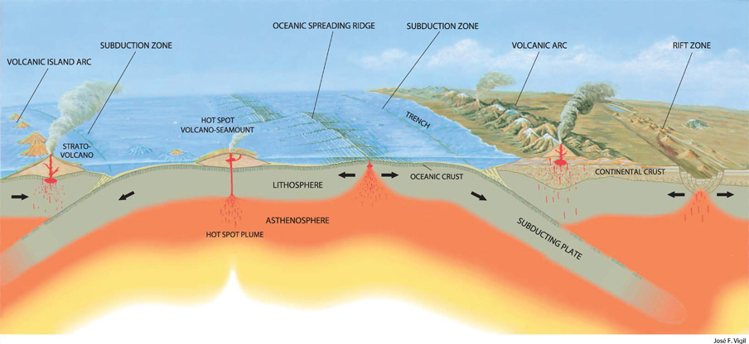
12. Where would the ocean floor be the oldest?
13. Where would the ocean floor be the youngest?
14. Where are the convergent boundary(s)?
15. Where are the divergent boundary(s)?

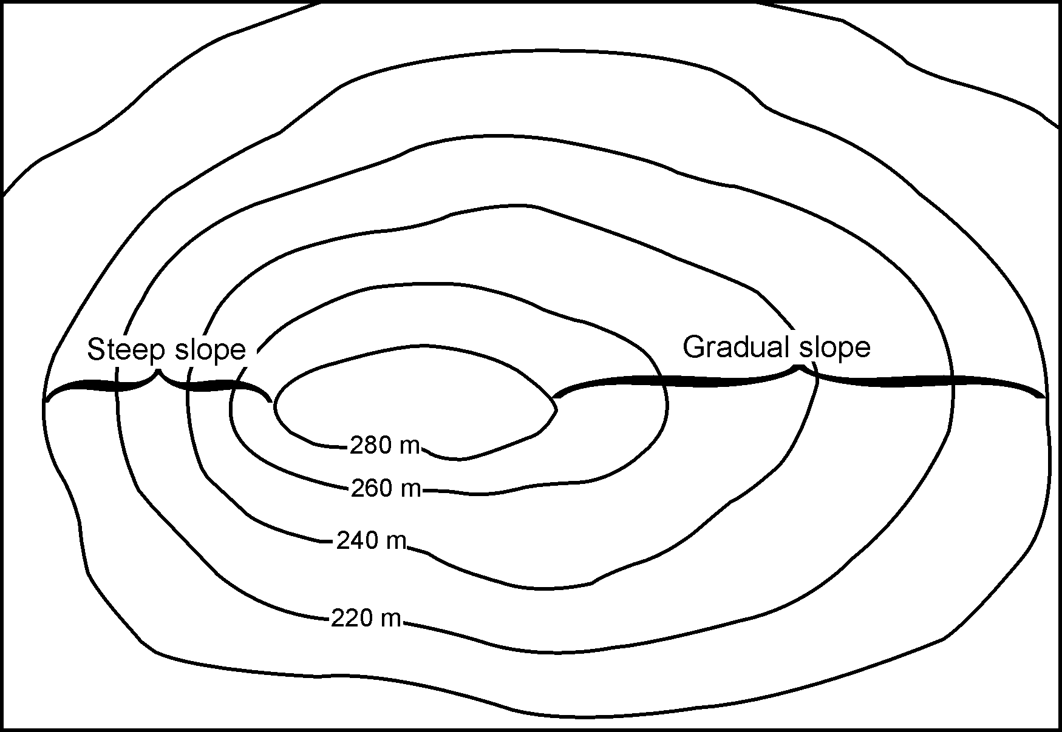
16. What is the relief on this map in meters?
17. What is the contour interval?

18. The sudden movement of the plate boundaries is caused by?

