Name: _______________________________________ Date: _______________ Period: _____

Final Exams 2018 Review

1. Fill in the following chart:
 | Charge | Location | AMU | Function/Role
Protons
Electrons
Neutrons

2. Following the instructions below to complete the periodic table:
a. Metals: circle/outline green
b. Metalloids: circle/outline yellow
c. Nonmetals: circle/outline blue
d. Alkali Metals: color red
e. Alkaline Earth Metals: color orange
f. Halogens: color purple
g. Noble Gases: color brown
h. Most Reactive Metal Group/Family: draw a star above this group/family
i. Most Reactive Nonmetal Group/Family: draw a star above this group/family
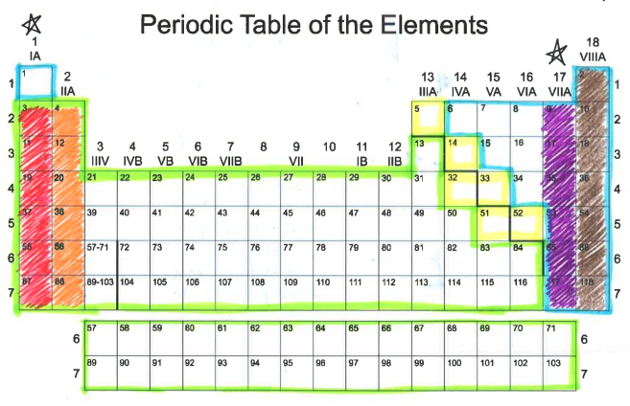
3. What do the following stand for?
a. A=P=E—
b. M-A=N—

4. Identify the following elements:

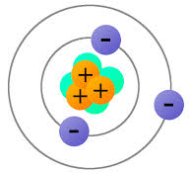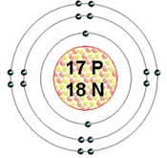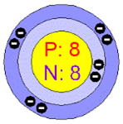

____________ __________ ____________________

Ecology

5. Explain the following ecological terms
a. Ecosystem—

b. Community—

c. Population—

6. Name the 3 types of Symbiotic relationships
a.
b.
c.

7. A bird eats ticks on a cow’s body. What feeding relationship is this?

8. The first level of a food chain begins with the Sun. TRUE/FALSE

9. What is the difference between a
a. Food chain—

b. Food web—

10. If producers are autotrophs, consumers will be known as___________

11.What do the arrows indicate on a food web and food chain?

12.Briefly describe the difference between
a. Parasite—

b. Host—

13.What is a decomposer?

14. Name 4 examples of decomposers
a.
b.
c.
d.

15. What are biotic and abiotic factors?

Biotic factors

Abiotic factors

16. Examples of biotic and abiotic are
a. Biotic Factors—

b. Abiotic Factors—

17. Give 4 examples of a predator-prey feeding relationships
a.
b.
c.
d.
e.

18. Define the following ecological terms
a. Mutualism—

b. Commensalism—

c. Parasitism –

19. What is the difference between the following?
a. Photosynthesis—The process where plants manufacture their food using CO2 + H2O and Sunlight
b. Chemosynthesis—

Lunar Phases, Tides, and Seasons

1. What causes seasons on Earth?

2. Where does the Earth’s axis pass through?

3. What angle does the Earth’s axis tilt?
4. Where does the Earth’s axis point?

5. Why is the Northern Hemisphere warm during the summer?

6. If it is winter in the Southern Hemisphere, what season is it in the Northern Hemisphere?

7. During what two months is the Earth’s axis not pointing toward or away from the Sun?

8. How much solar energy do the Northern and Southern Hemispheres receive during the spring and fall seasons?

9. Define tides.

10. Where do tides occur?

11. What causes tides?

12. How long does it take for the Moon to go through all its phases?

13. Why is the Moon visible?

14. Why isn’t the Moon visible during a new Moon phase?

15. What does ‘wax’ mean?

16. What does ‘wane’ mean?

17. Define spring tides.

18. Define neap tides.

19. How are the Sun, Moon, and Earth aligned during ‘spring tides’?

20. Describe when spring tides occur during the month.

21. Describe when neap tides occur during the month.

22. Is it possible to predict tides?

23. What does the Moon’s gravity do to the Earth’s waters?

24. Know how to label the 8 phases of the Moon.

ASTRONOMY—Universe

1. What is a light year?
a.

2. What is the definition of parallax?

3. What 3 ways are stars classified by?
a.
b.
c.

4. The hottest stars are what color?

5. What type of magnitude is it when stars brightness can be seen from earth?

6. In the HR diagram, the main sequence stars are what in relation to temperature and brightness?

7. What happens to make create a star?

8. What is the first stage in the life of a star?

9. What is the force that pulls matter in a nebula?

10. A star’s lifetime depends on what?

11. A supernova is the explosion of a dying_____________

12. The first thing that a star becomes when it runs out of fuel is?

13. How are black holes created?

14. What does a white dwarf become when it stops glowing?

15. How are elliptical galaxies and spiral galaxies different?

16. What type of galaxy is the Milky Way?

17. What is the name of the theory that astronomers developed to describe the beginning of the universe?

18. What is a piece of evidence that supports the big bang theory?

19. What did the solar system form from?

20. When the solar system formed, the sphere that lost most of their gasses became what?

21. The most massive stars become _____________ when they die.

22. What is the magnitude called when a star is a standard distance from the earth?

23. Galaxies without regular shape are classified as what type of galaxy?

24. Astronomers have said that our universe’s age can be inferred due to how fast the universe is:
a. Expanding or moving away
b. Shrinking
c. Making new stars
d. Making black holes

25. Some astronomers believe the universe began with an enormous explosion called ?

26. BE ABLE TO READ THE HR DIAGRAM AND ANSWER QUESTIONS ABOUT IT

27. When a white dwarf stops glowing, it becomes what color dwarf?

28. A neutron star forms from what other type of star?

29. What 2 ways can a star go after becoming a supernova?

30. What is the word that describes all of space and everything in it?

